
EstuaryWatch and Sedimentation Report
February 2023
Bruce Ferres
EstuaryWatch measurements and observations were recorded in January and February by Colin Wilkinson, Bruce Ferres and Beverley Ferres. Drone images by George Murley.
Estuary Mouth
The persistent northerly sand spit, and consequently more indirect flow of water into and out of the estuary, seems to be having an ongoing negative impact on the water quality in the estuary basin (see later item). A comparison of the current mouth condition with that of several years ago can be seen in the drone images below.
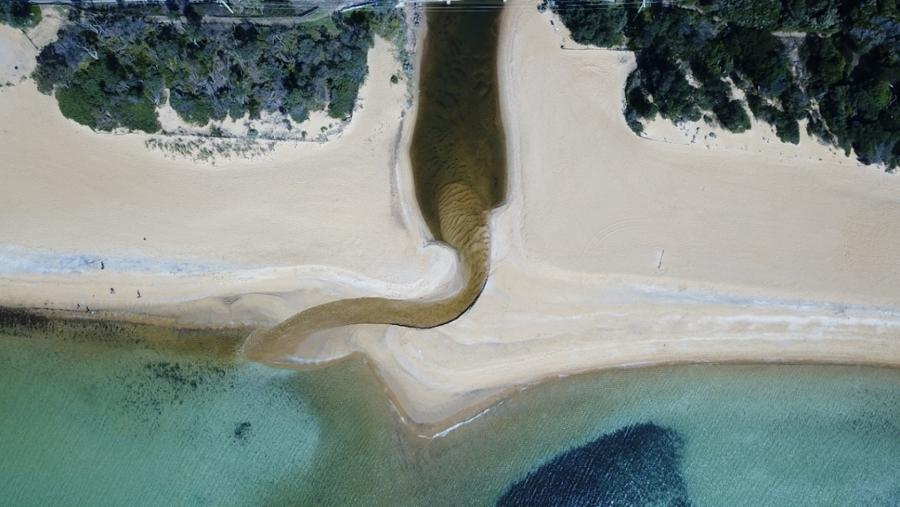
Estuary Mouth April 2020 (George Murley)
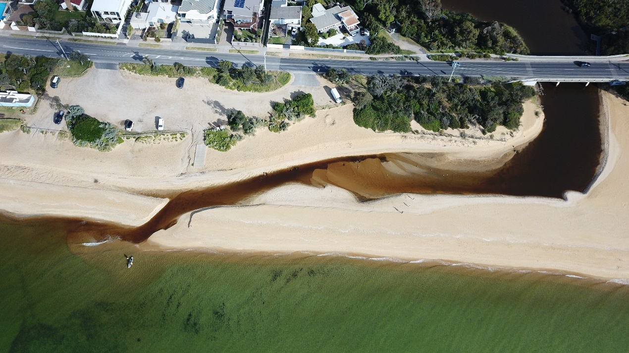
Estuary Mouth December 2022 (George Murley)

Estuary Water Quality Concerns
After the November 2022 storm deluge BERG was notified by SE Water that some of their assets were inundated causing spills into the creek. EstuaryWatch readings taken on Tuesday 6 December confirmed that while some improvement in turbidity had occurred, water clarity was still not back to historical levels. Readings taken in January 2023 show that NTU turbidity (a measure of water clarity) remains unacceptably high. Lower-level dissolved oxygen (DO) is still poor.
Water trapped in the basin behind a significant sand berm throughout December 2022 and January 2023 had a chemical profile closer to storm water than sea water. The exchange of sea water and creek water that usually occurs when the entrance is open, and the tide rises, was simply not taking place. This lack of regular flushing appears to be the result of altered entrance dynamics caused by the indirect northerly meander along the beach noted above.
Strong onshore winds combined with high tides saw a significant wash over breach of the berm in the first week of February 2023 causing minor flooding of the basin and a reintroduction of fresh sea water. However, it is important to note that this was not a breakthrough or opening of the mouth as in the past. The berm remained largely intact and continued to hold back the higher basin water in the days after the winds abated.
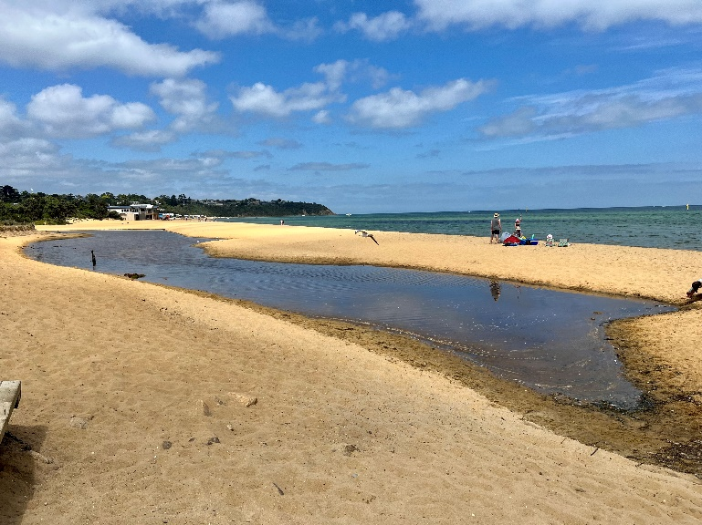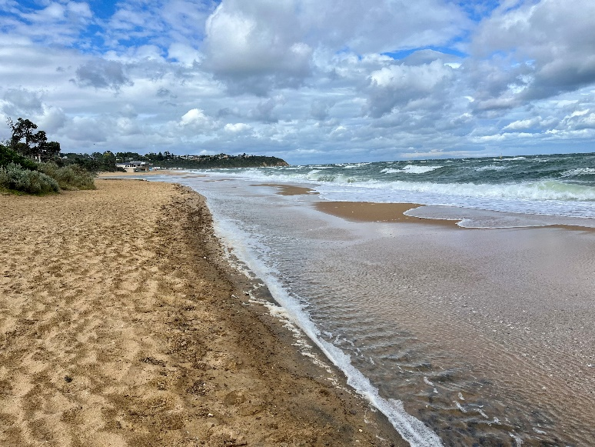
Entrance Berm January 2023 Berm is breached after strong NW winds on February 2 & 3, 2023
A true opening of the mouth occurred overnight on February 5th and this has set off the more usual ebb and flow of water in and out of the estuary basin in response to tidal cycles.
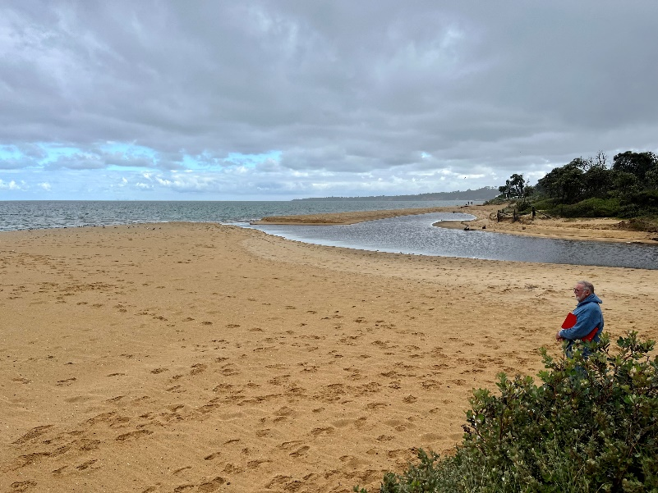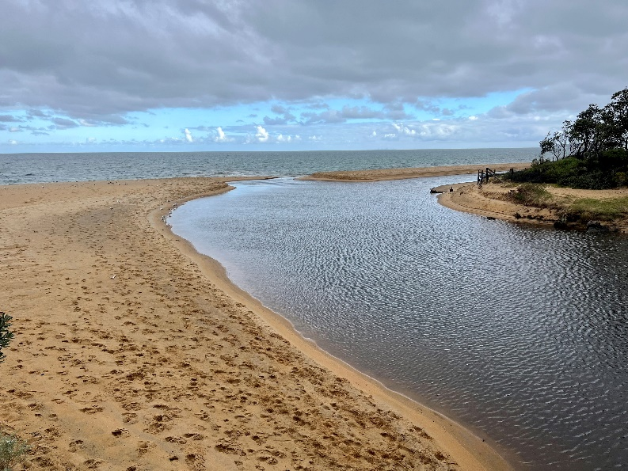
A more direct breakthrough an entrance opening occurred on February 5, 2023

Water Quality Monitoring Station: Draft Report
South East Water (SEW) and Balcombe Estuary Reserves Group Martha (BERG) have been working together to monitor for contaminants in Balcombe Estuary. A water quality monitoring station was deployed for monitoring ammonia levels and general water quality in real-time for 12 months (August 2021 – August 2022). The station fed data into a remote monitoring dashboard available to both organisations.
To better understand the background water quality in the estuary, SEW have extracted and analysed 12 months of historical data from the station dashboard. The analyses have been presented in a draft report and include summary statistics, influence of temporal variables such as seasons and time of day on indicators, relationship and correlation between indicators and a comparison with water quality guideline values. Through this we can determine the background water quality within the estuary for these parameters and expected normal ranges including for different seasons and time of day, an indication of estuary health through comparison of background levels with water quality guidelines and make recommendations for a suitable water quality threshold to alert of potential pollution events such as sewer spills.
The draft report is currently being reviewed by stakeholders and remains confidential until this process has been finalised. Bruce Ferres and Colin Wilkinson (EstuaryWatch) have been asked to provide feedback, including in-field observations and suggested edits. The final report should become more generally available by April this year.
BERG Sediment Pin
The BERG sediment pin was placed in the Henley Avenue sediment delta on April 1, 2020. An examination of the pin in December 2022, during the only time in recent months when the estuary basin water levels were sufficiently low, showed no significant increase in the depth of the sediment deposition. This suggests that recent sediment deposition has been spread out, expanding the size of the delta, rather than adding height to the existing deposit. Further drone images will be taken when the basin empties to see if this can be confirmed.
November Sewerage Spill Debrief with SE Water
BERG representatives Peter McMahon and Bruce Ferres met with SE Water personnel Paige-Elise Galloway (Community manager), Rebecca Goulding (Environmental Technical Lead) and Matt Maxwell (Senior Engineer Sewer Operations) on Tuesday 20 December for a debriefing on the sewerage spill into Balcombe Estuary after the storm deluge of November 2020.
SE Water has been working on a converting from a pumped waste disposal network in Mt Martha to a gravity system. The benefits are good as it’s better for the environment and the broader community as it doesn’t have energy or carbon emissions. Flows were transferred from a primary siphon to a secondary siphon to undertake these works. There are three siphons across Hopetoun Creek; siphon choice is determined by gravity and there’s no intervention. It was one of these secondary siphons that’s suspected to have leaked despite them having been recently assessed and passed. SE Water continuing investigations to determine possibilities around how the spill happened and what can be done to prevent it happening again. SE Water is determined to understand what happened to prevent a reoccurrence.

SE Water confirmed that it promptly notified the EPA about this incident. The protocol is that the EPA is involved when 200 litres or more has been spilled. The total volume of this spill is still not clear (it will form part of the investigations).

The meeting also resulted in a commitment to continue the sharing of information around spills so that the local community can be informed, in a timely manner, about adverse events. Work is continuing on the installation of multiple sensors that warn of spills. Some of the shortfalls of the ammonia sensor installed as part of the 24-hour monitoring station were further discussed. A combination of technical issues and location of the station limited the usefulness of data from this sensor and is the main reason why SE Water withdrew from funding its operation in 2023. However, BERG still appreciates the support SE Water provided for the trial period and the data extracted from the station over its one year of operation has resulted in some new understandings about seasonal variations in the biochemical profile of the Balcombe Estuary (see earlier item).

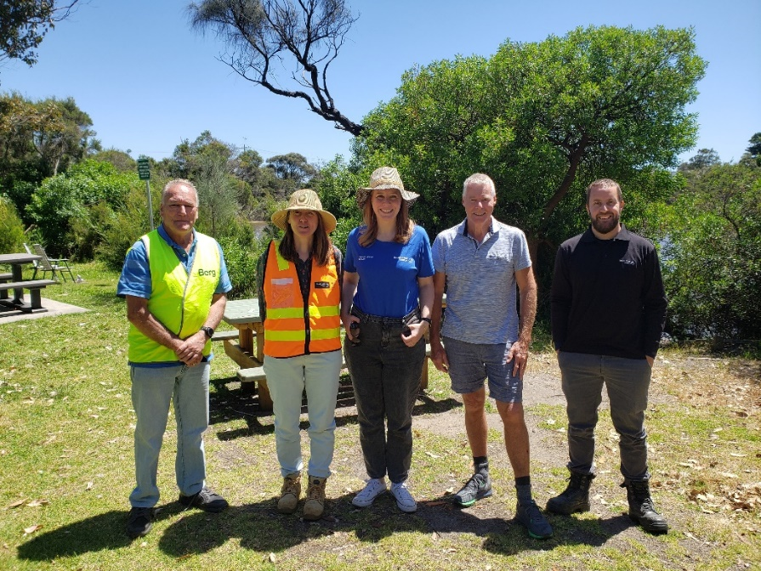
L to R: Peter McMahon, Rebecca Goulding, Paige-Elise Galloway, Bruce Ferres, Matt Maxwell
Henley Avenue Sediment Capture Pit Project
Mornington Peninsula Shire Council (MPSC) has now appointed a contractor to undertake construction of a bypass and sediment trapping storm water pit on the corner of Henley Avenue and Watsons Road.
An on-site meeting Wednesday 8 February was attended by representatives of BERG (Bruce Ferres & Peter McMahon), Mornington Peninsula Shire Council, Melbourne Water and the appointed contractors. Work on this project is slated to commence in two weeks’ time and expected to conclude early April 2023.
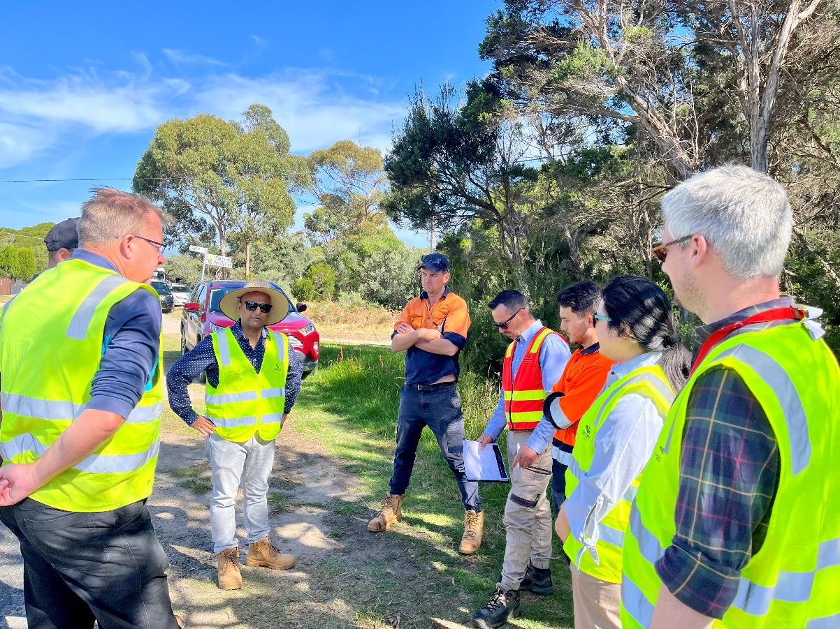
EstuaryWatch Team Volunteers
EstuaryWatch observations and measurements are carried out once each month. There are three test sites (picnic ground jetty, fishing platform near Ferrero Oval and at the August Street footbridge). It only takes a few hours, and no expertise is required. Why not join in, if only for one day, to see how it is done? You will be made very welcome.
Please contact Bruce Ferres (0435 389 804).

