EstuaryWatch and Sedimentation Report
August 2021
Bruce Ferres
EstuaryWatch observations and measurements were undertaken by Bruce Ferres and Jan Jones on Wednesday 4 August.
Mouth Conditions
The mouth of the estuary has been constantly opening and closing over the winter months. On the day of observations, the mouth was open and seawater water was pouring into the estuary basin due to a rising tide. In the last week water levels have been high causing minor flooding in the riparian zone. On several occasions the rotunda jetty was submerged.
Prevailing winds and tides have combined to both erode and build beach sand resulting in a very dynamic beach profile last month.
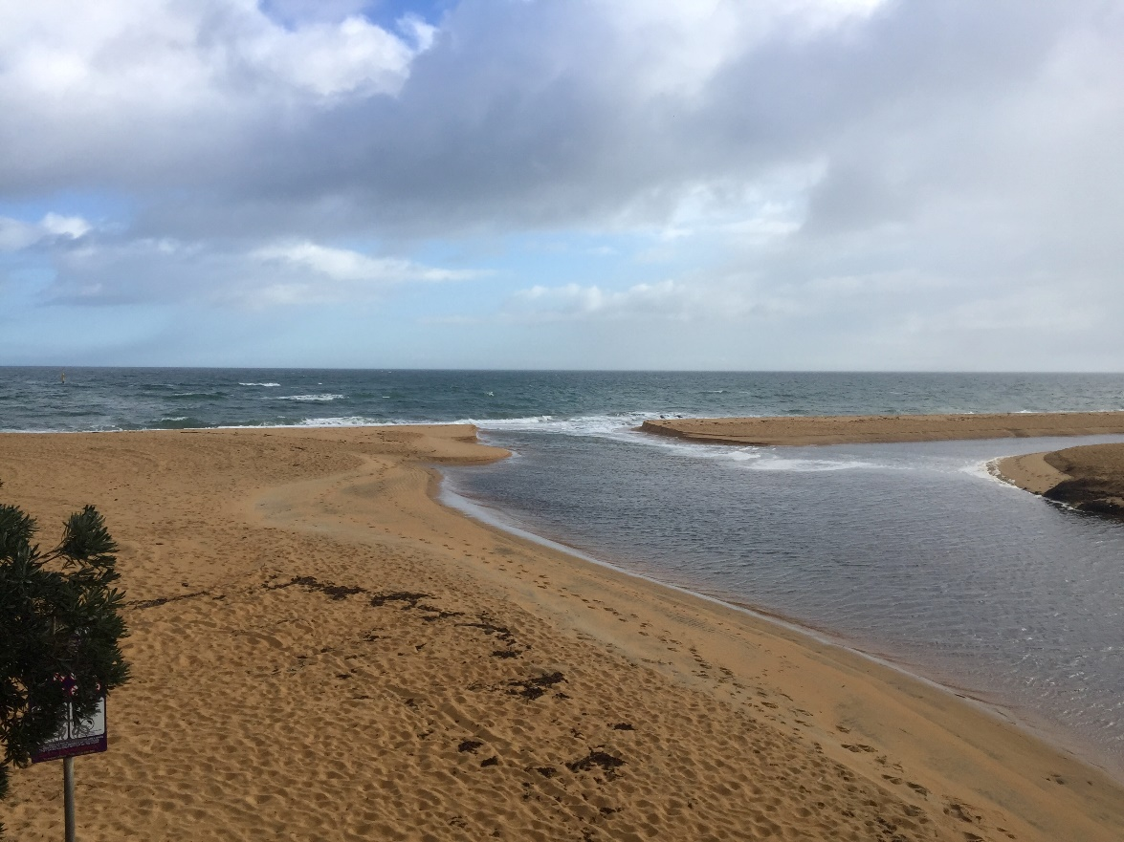
Balcombe Estuary mouth, August 4, 2021.
Our new pH meter enabled more accurate readings this month. The alkaline results reported in June and July will now be recorded as unreliable given that the old meter was probably malfunctioning. This month’s results are more consistent and within expectations given the very strong inflow of seawater under the influence of wind and tide. The inflow has been so strong that water samples taken at the Augusta bridge were far saltier than usual.

24-Hour Water Quality Monitoring Station
Installation of the station was delayed by recent Covid-19 restrictions and is now slated for later this month. Our grant application to Melbourne Water to cover funding for Years 2 & 3 of the project was acknowledged on July 28. The application will be reviewed by several MW teams and James Frazer (Coordinator, WaterWatch/EstuaryWatch). This will take some time and may require a BERG response to questions or the provision of further detail.

Henley Avenue Baffle Sediment Trap Project

The current status for the project is,

- Due to the requirements of MW, council had to take the design back to the drawing board. The new design is ready and is under review.
- Once the design is approved, it will go to the procurement phase and tendering.
- After tenders’ evaluation, the construction will commence.
- Parteek Mittal (Project Manager, MPS) is expecting construction will commence early next year.

Augusta Street Sedimentation Problems

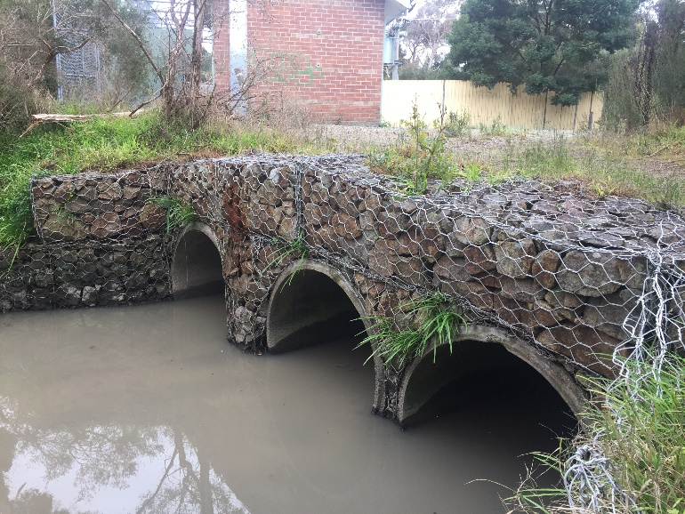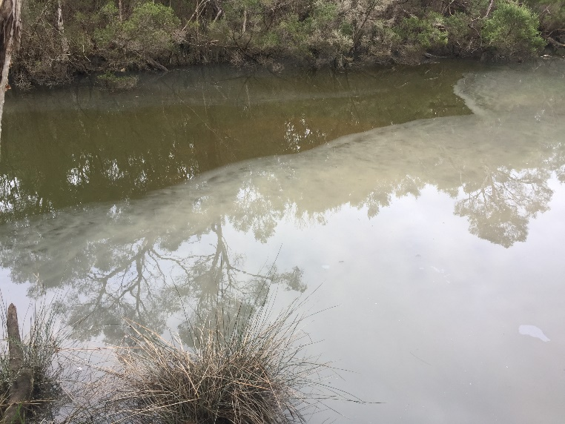
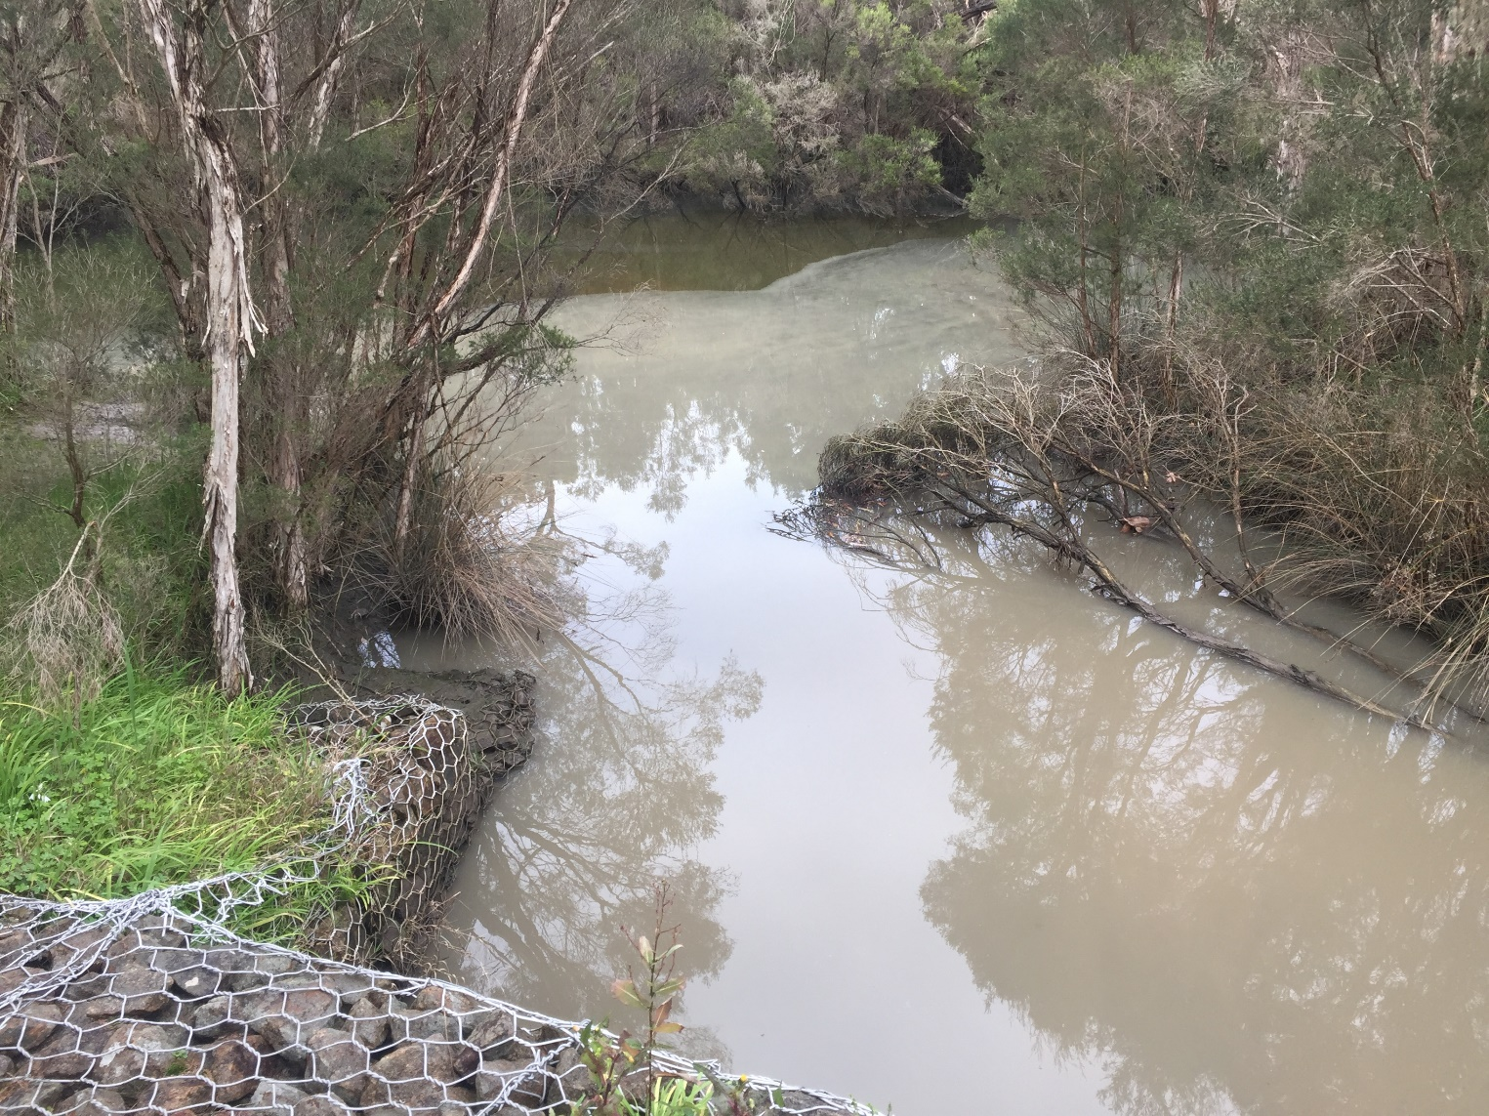
On Wednesday 14 July the Balcombe Creek was severely discoloured and carrying a huge sediment load. This continued for several days. The source of this silt and sediment laden water is the Augusta Street storm water outlet.
This problem seems to have been brought about by a combination of factors that include inappropriate or careless private earthworks at 30 and 33 Augusta Street (see images), a poorly rehabilitated depot site used by sewerage pipe contractors and road resurfacing/grading using gravel with a high clay to crushed rock ratio (see images).
BERG has protested the situation to MPS in the following terms,
“Sedimentation has already caused considerable damage to the estuary and poses a very real threat to its future. For many years now BERG has been urging MPS and Melbourne Water to undertake works and alter practices in an effort to reduce the impact of sediment laden storm water.
Some minor works have been undertaken with underwhelming results, others promised but to this point not delivered (e.g., Henley Avenue baffle pit project) and the proposed Long Term Sedimentation Reduction Action Plan is still not in place. All of this is bitterly disappointing and leads us to the obvious conclusion that neither MPS or Melbourne Water is treating this issue with the seriousness or urgency required.
BERG MM is seeking an urgent response that outlines how MPS will react to the current Augusta Street outfall sedimentation problem, and the factors contributing to it, along with an update on the proposed Long Term Sedimentation Reduction Action Plan.”
As yet no satisfactory response has been received. We will continue to follow up.

