EstuaryWatch and Sedimentation Report
June 2021
Bruce Ferres
EstuaryWatch observations and measurements were cancelled by Melbourne Water this month due to the Covid-19 lockdown restrictions.
Mouth Conditions
The mouth of the estuary opened briefly in early May but otherwise remained closed until Wednesday 9 June. The berm was breached after significant rainfall in the preceding few days.
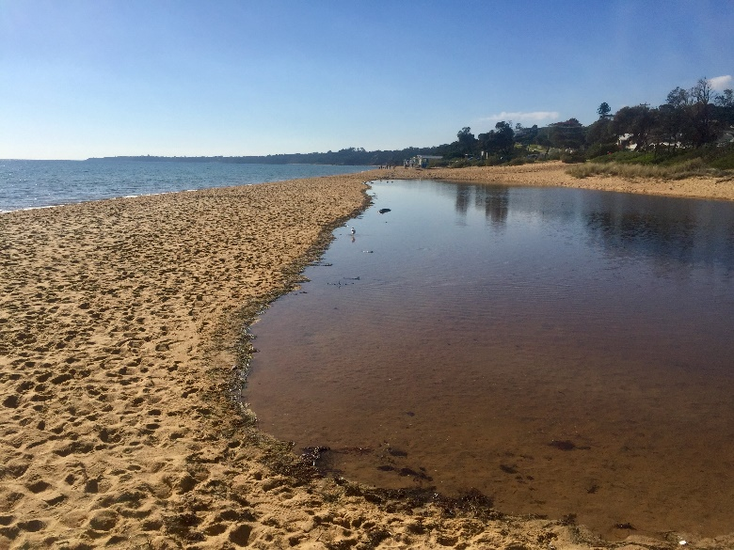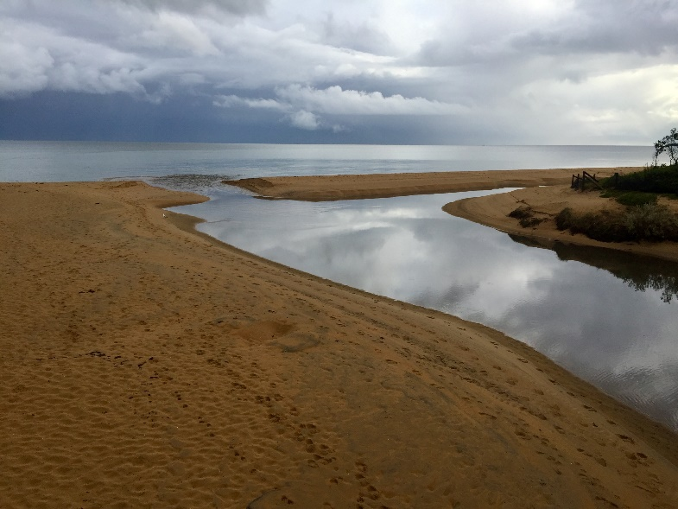
Balcombe Estuary Mouth on May 30, 2021 Balcombe Estuary Mouth on June 9, 2021

Sedimentation Action

MPS has now appointed a Project Manager for the Henley Avenue storm water by-pass sediment trap. He is ready to commence procurements and the letting of contracts immediately Melbourne Water approves the SPEL baffle-style pit construction plans. The project is now estimated to cost $400,000 and will be funded equally by Melbourne Water and MPS. Unfortunately, we still have no definite starting date but it is hoped that work will commence later this year.

SE Water Visit to the Estuary
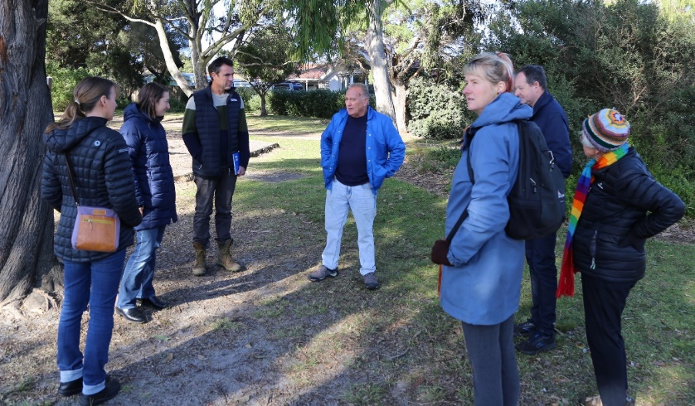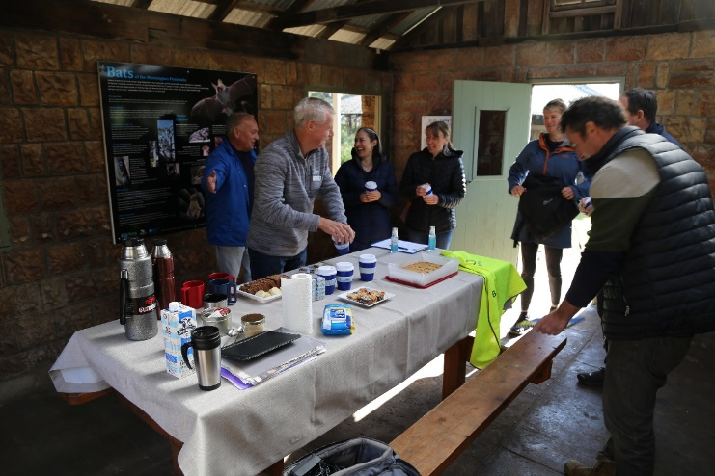
Peter and Sue introducing SE Water visitors to the audio trail Morning Tea in the Laundry
On Friday 21 May BERG MM hosted a meeting with SE Water representatives at the Balcombe Estuary Picnic Rotunda. BERG MM was represented by Peter McMahon (President), Bruce Ferres (Vice President) and Sue Milton (WaterWatch Coordinator).
The SE Water team consisted of,
Andrew Sieber - Group Manager Liveable and Sustainable Futures
Katrina Hermann - Environment Manager
Katrina (Kat) Hall - Environment Management System Specialist
Rebecca Goulding - Environmental Technical Lead
Jon Theobald - Community and Stakeholder Manager
Armaan Raj – Environmental Engineering Graduate.
The SE Water team were keen to learn more about Balcombe Estuary and the work of BERG MM with a view to establishing an ongoing dialogue and partnership. SE Water have already committed $17,500 of funding towards the installation of a 24-hour water quality monitoring station and are now keen to partner with BERG MM in an effort to raise community awareness about their work.
SE Water have expressed particular interest in the installation of a probe that will record levels of Ammonia (NH3). When combined with readings of Dissolved Oxygen (DO) and electroconductivity they believe the results will enable them to be alerted in real time to any unusual events or spills and more quicky react with the appropriate response.
The visitors were given a PowerPoint assisted presentation on BERG MM, took a walk along the boardwalk and were introduced to the Yellow Robin QR code supported audio trail. The visitors explained their various roles while enjoying a typical BERG MM morning tea. The SE Water team leader told the gathering that he was extremely impressed with the combination professionalism and enthusiasm displayed by BERG MM.

