EstuaryWatch and Sedimentation Report
July 2021
Bruce Ferres
EstuaryWatch observations and measurements were undertaken by Bruce Ferres and Jan Jones on Tuesday 6 July.
Mouth Conditions
The mouth of the estuary has been open and closed several times in the recent month. On the day of observations, the mouth was open and fresh salt water was pouring into the estuary basin due to a rising tide. In the last week water levels in the basin have been very low providing rich feeding grounds for a number of wading birds.
Prevailing winds and tides have combined to deposit more sand than usually seen on Mt Martha beach at this time of year. The build-up on the North Beach and at the entrance is particularly noticeable.
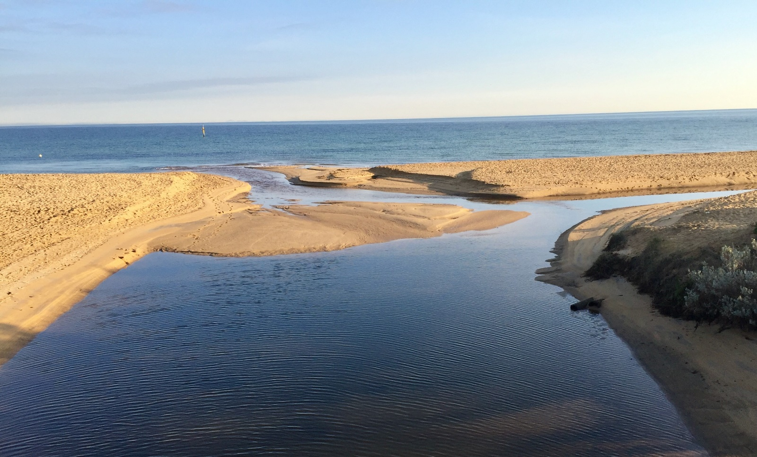
Balcombe Estuary mouth, July 8, 2021.

24-Hour Water Quality Monitoring Station
Further negotiations between BERG, Bio2Lab Pty Ltd and SE Water have resulted in SE Water now agreeing to fully fund a multi parameter 24-Hour Monitoring Station in the Balcombe Estuary for 12 months. At a cost of $20,000, this monitoring station will provide real time feedback on salinity, temperature, dissolved oxygen, pH, ammonia and turbidity. Our submission to Melbourne Water will be amended to reflect this development and will now focus on the need to secure funding for the following 2 years.
A second on-site visit took place on Monday 28 June. It was attended by Bruce Ferres (BERG), Rebecca Goulding & Aarman Raj (SE Water) and Dr Dave Sharley & Steve Marshall (Bio2Lab). The purpose of this visit was to determine the most appropriate location for the monitoring station. It was agreed that the rotunda jetty site would best capture the water quality profile of the estuary. A further advantage of this site is that informational/educational signage sponsored by SE Water and BERG could be included. It is hoped that installation will commence later this month.

Sedimentation Pin

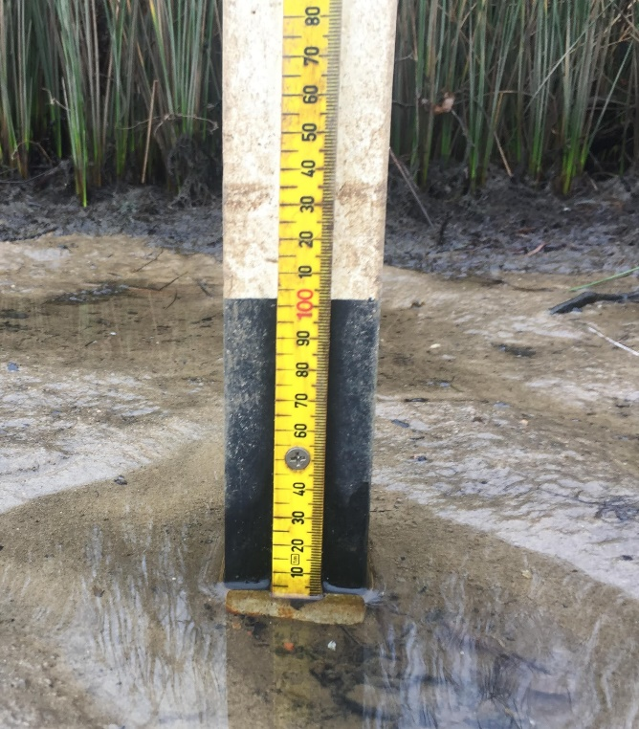
Low water levels in the estuary last month provided an opportunity to inspect the Sediment Pin installed by BERG in April this year. The pin appears to have remained stable and is in good condition. As expected, the level sediment has remained unchanged. This is a long-term project and readings need to be taken over several years.

We know that seagrass can only tolerate a sediment build-up of less than 2cm per year and so it is important to understand the challenges facing re-introduction of this fundamental food web plant. If this trial pin proves to be stable and provides us with useful data, then many more in other locations will be needed to build up a comprehensive picture of sediment deposition.

Eels Signage

While on a recent walk at Barwon Heads I noticed this information sign at the side of the estuary. Perhaps we could do something similar with the currently empty display frame on the estuary side of the picnic ground rotunda? The poster on short-finned eels in the Camp Laundry is excellent for those seeking detailed information but the simplicity of this message and a more visible location might prove to be a winner?





