EstuaryWatch and Sedimentation Report
May 2021
Bruce Ferres
EstuaryWatch observations and measurements this month were undertaken by Bruce Ferres and Jan Jones.
Mouth Conditions
The mouth of the estuary closed early in April and has not been under pressure due to typically stable Autumn weather conditions combined with a lack of rain.
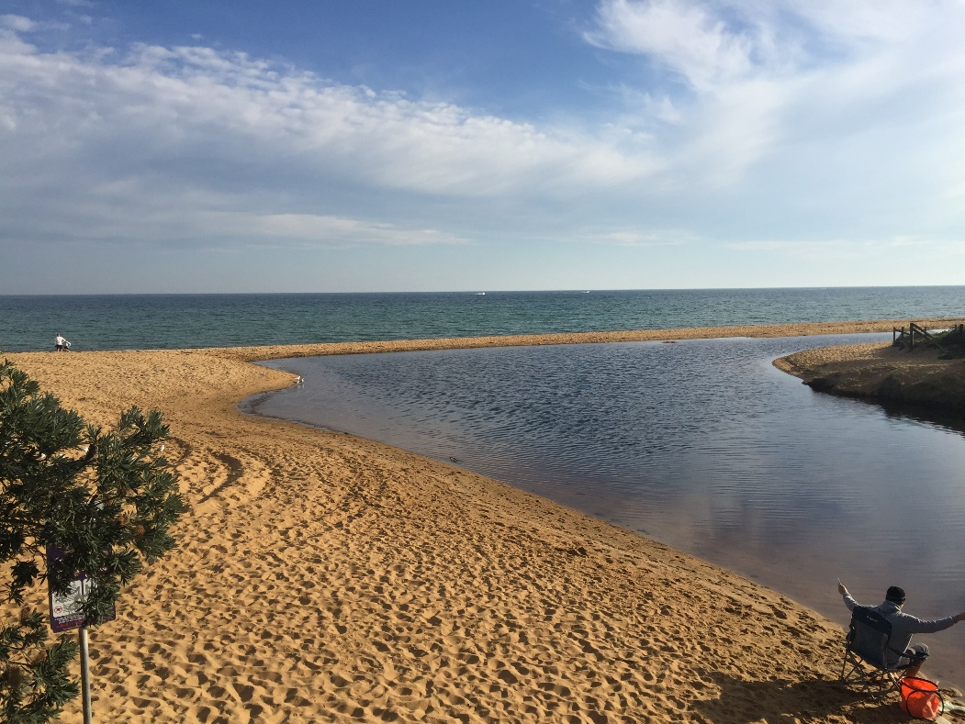
The estuary waters have been held back by a berm for most of April and are now perched over 50 cm higher than the bay.
Moderate rainfall during the evening of Monday 3 May caused the estuary waters to rise beyond the height of the rotunda jetty platform but the berm held firm.
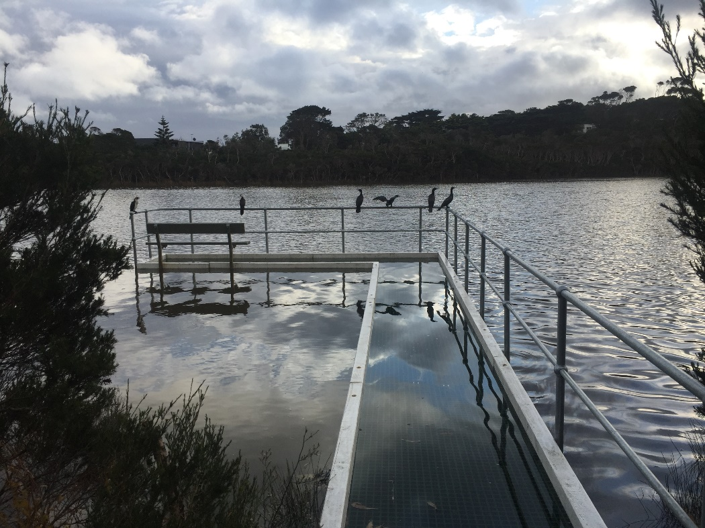
A group of cormorants perched on the flooded rotunda jetty on the morning of 04/05/21.
Estuarine Water Quality
Turbidity and saline levels were good to excellent as expected given the prevailing conditions of the last month. Of some concern was the alkalinity of the water at all testing sites. Test results over pH 8 suggest contamination by fertilisers or detergents. The WaterWatch team reported higher than expected phosphate levels upstream last month and perhaps the EstuaryWatch results are now picking this up further downstream. This may be resolved when the entrance opens and the collected water in the basin is flushed into the bay.
Short-Finned Eel Study
The Arthur Rylah research team returned to Balcombe Estuary in April but were unable to add to the tally of three eels caught and fitted with transmitters last month.

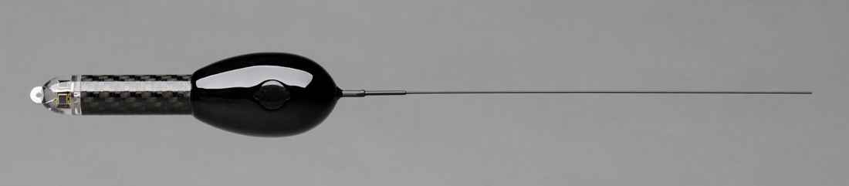
Transmitter device fitted to three eels migrating from the Balcombe Estuary last month.

Sedimentation Action

The Henley Avenue project is now expected to be delivered in August/September 2021 as the wet weather has begun and some key procedures (maintenance agreement, incentive application, product & contractor procurement) are yet to be finalised. MPS is hoping to provide further updates within the next 2-3 weeks.

MPS is organising a meeting between BERG representatives and Councillors (Thursday 20 May) to present the draft Long Term Sediment Minimisation Plan and seek feedback. There will also be an update regarding another project proposed for the next financial year which ties in with one of Shire projects at Mt Martha Golf course.

In the meantime, even moderate rain events are resulting in erosion and increased sediment laden inflows to the estuary. Rain experienced during the night of Monday 3 May resulted in damaging storm water flows in both Newton (below Alice St) and Ernest Streets adjoining the estuary.

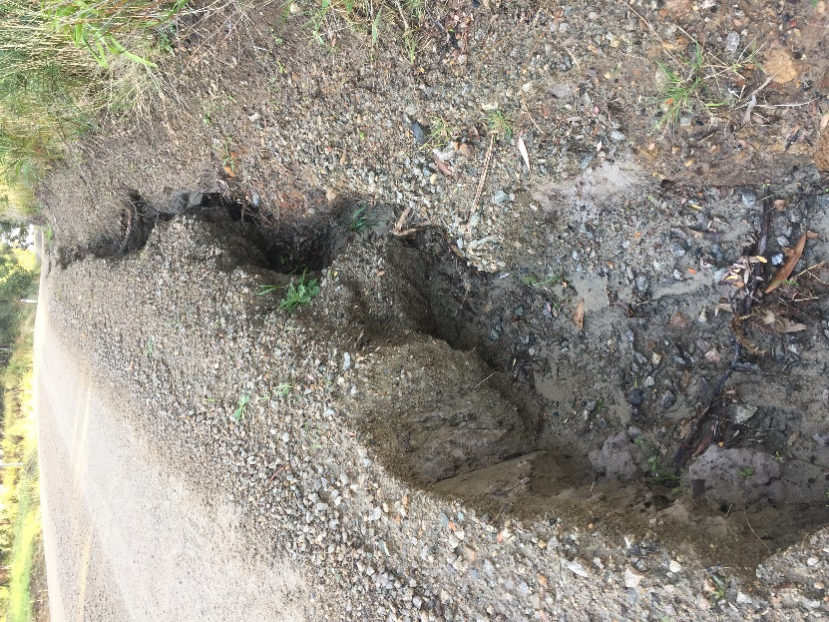
Newton St below Alice St on the morning of 04/05/21

Perhaps it is time to consider compulsory rain gardens and/or water tanks for dwellings on unmade roads so that household storm water is not directly emptied into easily eroded ditches?
SE Water Agrees to be a Co-Contributor
The BERG application to Melbourne Water for funding to install and maintain a 24-hour monitoring station in the Balcombe Estuary will be finalised and submitted by the end of May 2021. Discussions with SE Water, Mornington Peninsula Shire, Bio2Lab Pty Ltd and Mt Martha LSC have been on-going.

In a major boost to our application SE Water have agreed to become a co-contributor by meeting the cost of the ammonia sensor. This sensor will enable the detection of sewerage spills and provide on-going background data that will tell us much about estuary health. Installation, maintenance and data feedback from this sensor is estimated to cost SE Water $17,000 over three years.

This contribution is noteworthy and increases the likelihood of our application being successful because it demonstrates to Melbourne Water that BERG has been able to build a significant partnership with an important stakeholder and it reduces the size of the grant being sought.

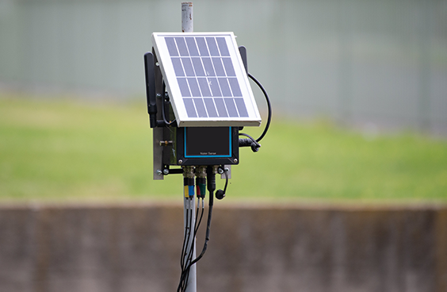
A Bio2Lab 24-hour monitoring station (above water view) recently installed in Dandenong Creek.

