EstuaryWatch and Sedimentation Report
March 2021
Bruce Ferres
EstuaryWatch observations and measurements were undertaken by Bruce Ferres, Jan Jones, and Bev Ferres from 7-9 April.
Mouth Conditions
The mouth was closed by a substantial berm for most of February. Unusually low rainfall has meant that water levels in the estuary remained fairly consistent and placed no real breakthrough pressure on the sandy barrier preventing flows into Port Phillip Bay. In the absence of a storm event featuring strong south winds, it is anticipated that the entrance will remain closed in the near future.
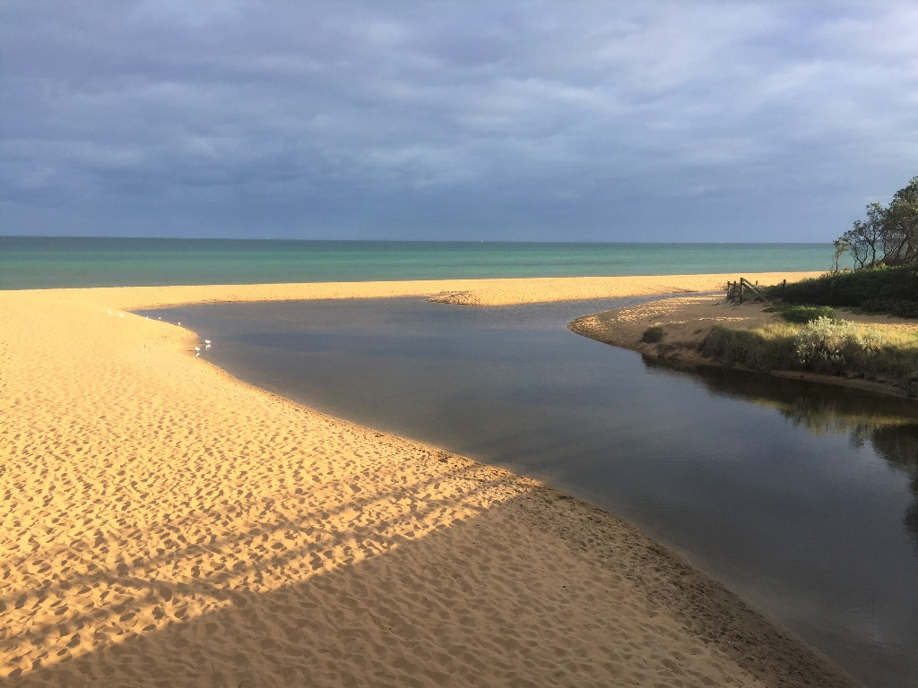
A 18m wide berm keeps the estuary waters perched above sea level (03/03/21)
Estuarine Water Quality
In the upper reaches of the estuary the top layer of water was fresh with a salt wedge at about 1 metre but in the estuary basin the water is consistently salty. The pH reading at the rotunda jetty and oval fishing platform was more acidic than usual so this will need to be monitored. Some supplementary measurements will be taken in the next few weeks.
All other parameters such as dissolved oxygen, acidity, and turbidity fairly consistent with base line data although the dissolved oxygen at the lowest levels were very low. This was associated with a noticeable sulphur dioxide odour when fine bottom sediments were disturbed.
Short-Finned Eel Study
The BERG EstuaryWatch team is assisting in a new study of Short-Finned Eels. In the past individual eels have been tagged and then caught nearly 4,000 km away in the Coral Sea but the route they took to get there is currently only a matter of speculation. In this new study, for the first time, a number of eels will be caught and equipped with electronic transmitters enabling their journey to be tracked.

It is expected that the eels will migrate about the time of the Easter new moon. The researchers asked for assistance in checking the estuary mouth with photo monitoring in the lead up to the proposed capture dates. Our first report was sent on Tuesday 2 March. Just after sunset on Saturday 6 March, junior BERGers, Myra Ferres (7) and Kai Ferres (4) scanned the estuary waters with their torches looking for eels but disappointingly were only able to spot a few bream! Let’s all keep a sharp eye out for any signs the migration is underway.

Liveable Communities, Liveable Cities Funding Application
Work around the application to Melbourne Water for funding to install and maintain a 24-hour monitoring station in the Balcombe Estuary focussed on partnership building during February. Discussions were held with representatives of SE Water, Mornington Peninsula Shire, EPA Victoria, Bio2Lab Pty Ltd and Mt Martha LSC.

Most responses have been very positive. SE Water has arranged for relevant personnel to meet with BERG on-site on Friday 23 April and will look into the possibility of becoming co-contributors. Discussions with Anthony Bigelow (First Friends of Dandenong Creek) were really helpful. Their experience with these kinds of monitoring stations will usefully inform the way we go about presenting our case. It is hoped we will be able to have the final submission ready to go by the end of April.

Sedimentation Update

When responding to the draft MPS Long-Term Sediment Minimisation Plan BERG once again made the case for the installation of sediment pins so that the rate of sediment deposition can be monitored. BERG was advised that this was under consideration. Rather than wait for the bureaucratic wheels to slowly turn on this matter I decided to build a prototype that is now ready for testing. After gaining MPS approval the idea is to install the trial sediment pin on the seaward side of the Henley Avenue outfall sediment plume. The sediment pin is designed for manual and laser measurements.

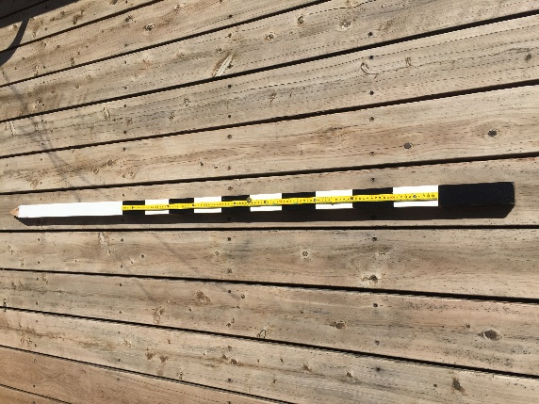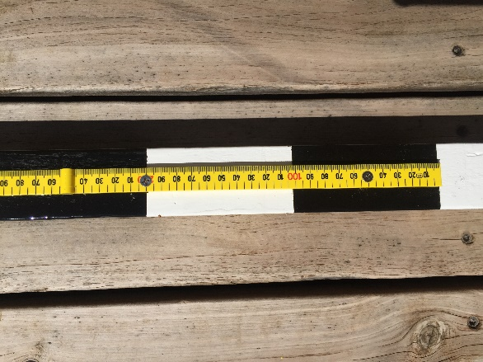
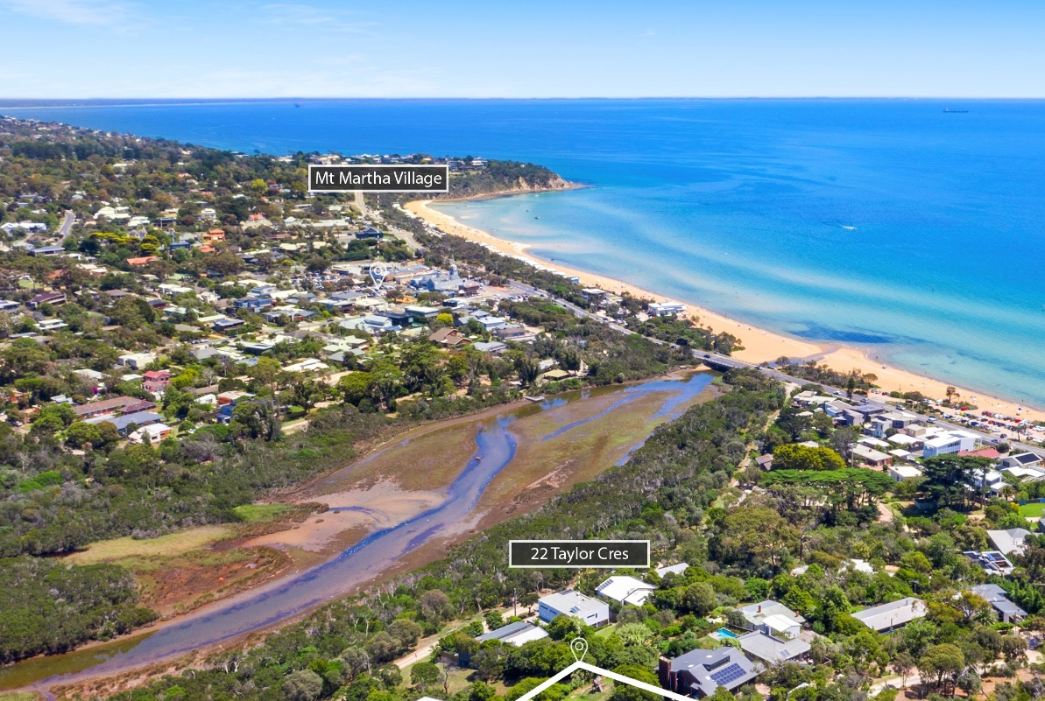
This drone image was used on a board advertising the sale of 22 Taylor Crescent last year. After contacting Warlimont and Nutt they kindly forwarded me a copy. A very clear (and somewhat alarming) view of the Henley Avenue outfall and sediment deposition.
Advance College Visit
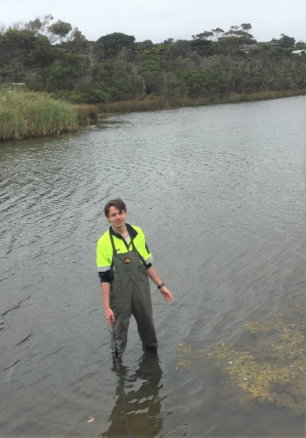
A group of young adults from Advance College, Rosebud visited the Balcombe Estuary on Thursday 4 March to take part in some environmental studies activities organised by Jacqui Salter (MPS Community Environmental Officer). Jacqui invited BERG to speak to the group about EstuaryWatch, so a short talk was given accompanied by a demonstration of water sampling.
One of the visitors donned the EstuaryWatch waders and helped carry the multimeter probe into deeper water. They all enjoyed the very “hands on” experience.
Advance College provides courses of study that aim to engage young adults who have struggled within, or experienced difficulties with, traditional educational settings.

Snap Send Solve
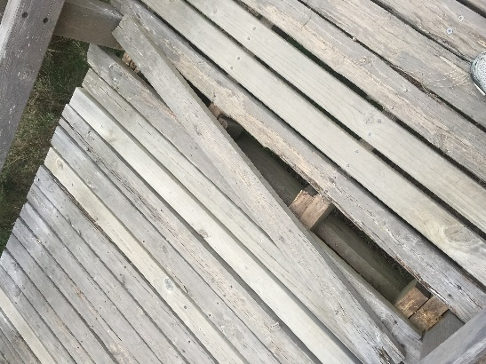
The Snap Send Solve App is a really useful way of reporting problems that require the Shire’s attention. This image, taken on the Augusta St footbridge, was uploaded to the app and repairs were completed within two days.

Birds
Earlier this month a single Black Swan was observed swimming along the estuary and on another day three were observed flying over. For the last three weeks a single Eastern Great Egret has been fishing in the shallows along the estuary shoreline and, at times, has been observed quite close to the Esplanade Bridge. A White-Faced Heron has been seen flying along the creek near the Ferrero Oval platform. Cormorants and Coots have been enjoying the more consistent water levels in the estuary.

