EstuaryWatch and Sedimentation Report
February 2021
Bruce Ferres

EstuaryWatch observations and measurements were undertaken by Bruce Ferree, Jan Jones and Colin Wilkinson on Sunday 7 February. The new YSI Pro 2030 multimeter performed well and has increased both the speed and accuracy of results.
Mouth Conditions
The estuary mouth was open for most of January. The unusual shape of the berm continues to be influenced by the stockpile of sand (believed to be around 3,000 m3) that was left near the entrance when sand shifting operations were abandoned. Strong winds and heavy rain over a short period saw the mouth open again on Friday 5 February. The state of the mouth at the time of observations suggested that an exchange of water was probably only occurring at high tide and with the assistance of south westerly winds.
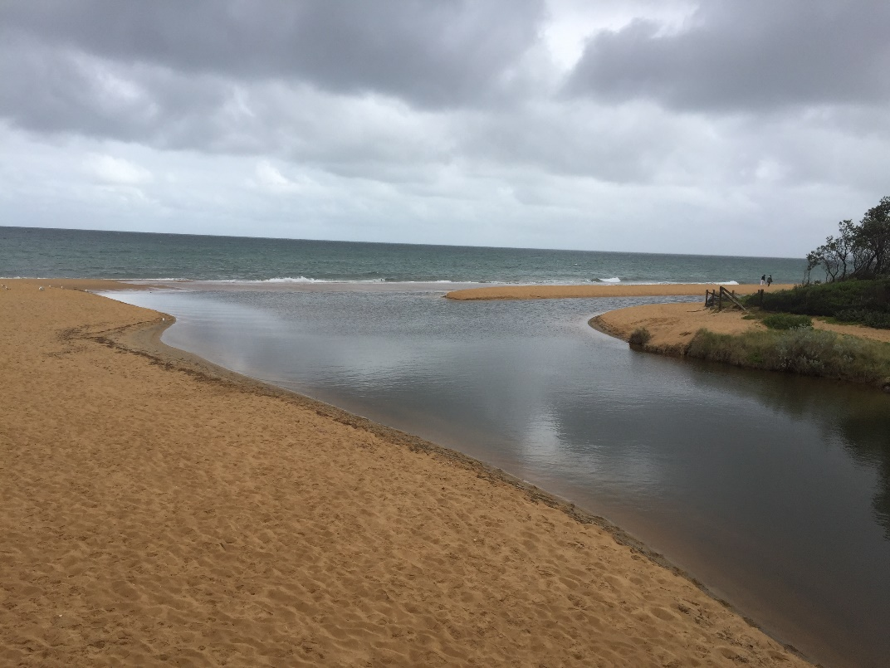
Balcombe Estuary Mouth, February 7, 2021
Estuarine Water Quality
The temperature of water in the estuary has cooled by around 6 degrees since January and currently averages around 19 degrees. This was undoubtedly influenced by very recent heavy falls of rain. In the upper reaches of the estuary the top layer of water was fresh, although laden with fine sediments, with the salt wedge not noticeable until a depth of 1 metre. This is also a reflection of recent and moderate to heavy rainfall in the catchment.
All other parameters such as dissolved oxygen, acidity, and turbidity were consistent with recordings made during summer period in previous years.
Short-Finned Eel Study
The BERG Estuary Watch Team has been asked to assist in a new study of Short-Finned Eels.

Scientists from Arthur Rylah Institute (ARI) have been engaged by Melbourne Water to undertake studies into the life history of short-finned eels (in particular responses to waterway flows). Part of the study involves capturing adult eels on their downstream migration and attaching satellite transmitters. These eels will then be remotely tracked to their breeding grounds, which are expected to be around the Coral Sea, where they will spawn before they are presumed to die. The majority of eels are thought to migrate during periods of decreased illumination (on a new moon) in autumn, so the plan is to capture and tag approximately 6 adult eels during the period of 9-19th March 2021.

Prior to the proposed fieldwork dates, we need to monitor the status of the estuary. The researchers are looking for assistance checking the estuary mouth with photo monitoring for approximately 10 days in the lead up to the proposed monitoring dates, and potentially a few additional days. This will involve emailing a photograph and any commentary about the status of the estuary (including any observations of fish) to Wayne Koster (ARI scientist).

This fieldwork was initially planned for 2020 but was postponed due to COVID-19. It is unknown how many (if any) eels will be captured from Balcombe estuary until the fieldwork is completed. As such, promotion of this activity must be held off until after the eels are tagged (in case of covid-related postponement or lack of eels). The researchers are keen to work with the BERG EstuaryWatch team to communicate the project (including EstuaryWatch involvement and movements of the eels), and members of the team may be invited to see the eel nets if they are interested.

Liveable Communities, Liveable Cities Funding Application
Preparation of the application to Melbourne Water for the funding to install and maintain a 24-hour monitoring station in the Balcombe Estuary, Mount Martha is underway. A backgrounding introduction has been written together with an explanation of how the proposed project meets the guiding principles and themes of the funding program. Each of the criteria for a successful application will need now to be addressed. The progress draft can be viewed on the BERG G:Drive > Submissions & Presentations> DRAFT Monitoring Station Funding Application.

We are keen to build a partnership between BERG MM, SE Water, Mornington Peninsula Shire and Bio2Lab as we move forward with this application and will also be seeking support from the Mt Martha LSC.

